**Title**: A holistic approach of Comparative Analysis of Independent Component Analysis and Principal Component Analysis of Electromyographic Movement Detection using Machine Learning and Deep Neural Network

**About the Dataset**

**Data Manipulations**

Stimulus Value == Re-Stimulus Value

Repetition Value == Re-Repetition Value

Rest Values are redundant value and Outliers so they are dropped from the Dataset.

**System Work Flow:**

**Deep Learning Architecture**

**Feature Selection**

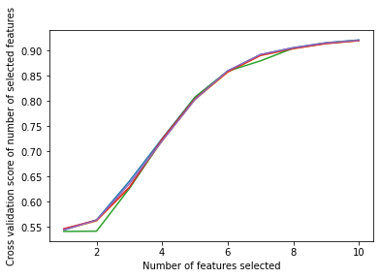

**Figure:** How Accuracy is Increasing by Selecting each Features (Wrapper Method: RFE Feature Selection)

|  |  |
| --- | --- |
| Features | Boruta Feature Selection |
| Emg 1 | True |
| Emg 2 | True |
| Emg 3 | True |
| Emg 4 | True |
| Emg 5 | True |
| Emg 6 | True |
| Emg 7 | True |
| Emg 8 | True |
| Emg 9 | True |
| Emg 10 | True |

**Table:** Optimal Number of Feature Selected by Boruta Feature Selection (Wrapper Method)

**Accuracy Table**

|  |  |  |  |  |  |  |
| --- | --- | --- | --- | --- | --- | --- |
| Machine Learning Algorithms | Default Machine Learning | Tuned Machine Learning | PCA Default Machine Learning | PCA Tuned Machine Learning | ICA Default Machine Learning | ICA Tuned Machine Learning |
| Decision Tree | 83.87301502 | 84.57953147 | 81.39559326 | 82.13468716 | 81.40368433 | 82.49789598 |
| KNeighborsClassifier | 88.66188486 | 91.86992259 | 90.78938851 | 92.50547478 | 90.37949589 | 92.80727515 |
| ExtraTreesClassifier | 93.09959929 | 93.20212129 | 92.29460601 | 92.40082481 | 92.53671022 | 92.66604751 |
| Random Forest | 92.57993407 | 92.90066812 | 91.07826543 | 91.5361177 | 91.59215058 | 91.9792397 |
| XGBoost | 86.51984381 | 92.08704824 | 85.05111864 | 90.66070434 | 85.66737119 | 91.10851112 |

**F1 Score Table**

|  |  |  |  |  |  |  |
| --- | --- | --- | --- | --- | --- | --- |
| Machine Learning Algorithms | Default Machine Learning | Tuned Machine Learning | PCA Default Machine Learning | PCA Tuned Machine Learning | ICA Default Machine Learning | ICA Tuned Machine Learning |
| Decision Tree | 0.838880165 | 0.845838755 | 0.813353449 | 0.821184835 | 0.814084792 | 0.824775073 |
| KNeighborsClassifier | 0.883871547 | 0.917993206 | 0.904663498 | 0.924824763 | 0.901666605 | 0.927817624 |
| ExtraTreesClassifier | 0.929752135 | 0.93038057 | 0.920960038 | 0.922528568 | 0.923921676 | 0.925525494 |
| Random Forest | 0.924418467 | 0.927714547 | 0.910175065 | 0.913552513 | 0.914125864 | 0.918142558 |
| XGBoost | 0.861418861 | 0.919841428 | 0.845406878 | 0.904945033 | 0.852159738 | 0.909559142 |

**Mean Absolute Error Table**

|  |  |  |  |  |  |  |
| --- | --- | --- | --- | --- | --- | --- |
| Machine Learning Algorithms | Default Machine Learning | Tuned Machine Learning | PCA Default Machine Learning | PCA Tuned Machine Learning | ICA Default Machine Learning | ICA Tuned Machine Learning |
| Decision Tree | 1.223799993 | 1.170422953 | 1.412828553 | 1.356685629 | 1.414806233 | 1.326968785 |
| KNeighborsClassifier | 0.893675588 | 0.67042405 | 0.739651009 | 0.632180266 | 0.769080739 | 0.598948711 |
| ExtraTreesClassifier | 0.5818269 | 0.580137393 | 0.642441075 | 0.637902997 | 0.626667366 | 0.619371754 |
| Random Forest | 0.609006818 | 0.586495623 | 0.712584872 | 0.709183546 | 0.68549935 | 0.658338042 |
| XGBoost | 1.015560737 | 0.625891098 | 1.138653038 | 0.736524987 | 1.093931887 | 0.699943839 |

**Mean Squared Error Table**

|  |  |  |  |  |  |  |
| --- | --- | --- | --- | --- | --- | --- |
| Machine Learning Algorithms | Default Machine Learning | Tuned Machine Learning | PCA Default Machine Learning | PCA Tuned Machine Learning | ICA Default Machine Learning | ICA Tuned Machine Learning |
| Decision Tree | 13.74420649 | 13.14170439 | 15.85917532 | 15.23744897 | 15.92978883 | 14.91061663 |
| KNeighborsClassifier | 10.26794797 | 7.754611173 | 8.498997273 | 7.169670553 | 8.878348165 | 6.949328439 |
| ExtraTreesClassifier | 6.844287546 | 6.847988034 | 7.52317022 | 7.514671199 | 7.373344651 | 7.326953092 |
| Random Forest | 7.097258307 | 6.859216805 | 8.28946379 | 8.100743333 | 7.983761051 | 7.693786156 |
| XGBoost | 11.36651351 | 7.155512979 | 12.82170081 | 8.451298166 | 12.34577603 | 8.013052265 |

**Root Mean Square Error Table**

|  |  |  |  |  |  |  |
| --- | --- | --- | --- | --- | --- | --- |
| Machine Learning Algorithms | Default Machine Learning | Tuned Machine Learning | PCA Default Machine Learning | PCA Tuned Machine Learning | ICA Default Machine Learning | ICA Tuned Machine Learning |
| Decision Tree | 3.677761773 | 3.593348962 | 3.954470429 | 3.875401787 | 3.963820149 | 3.831946561 |
| KNeighborsClassifier | 3.168100715 | 2.724426013 | 2.876566239 | 2.613217365 | 2.941846123 | 2.567853762 |
| ExtraTreesClassifier | 2.571159842 | 2.570385068 | 2.70134794 | 2.701348198 | 2.673206854 | 2.663881336 |
| Random Forest | 2.621810374 | 2.575215962 | 2.84175962 | 2.808435334 | 3.033998869 | 2.733896227 |
| XGBoost | 3.335237773 | 2.631389287 | 3.549147903 | 2.867498637 | 3.691980189 | 2.790484694 |

**Deep Learning Results**

|  |  |
| --- | --- |
| Parameters | Mean Results |
| Training Accuracy | 0.948078 |
| Validation Accuracy | 0.9335 |
| Training Loss | 0.166563 |
| Validation Loss | 0.229119 |
| Accuracy | 93.35039 |
| F1 Score | 0.932607 |
| Mean Absolute Error | 0.538913 |
| Mean Squared Error | 6.209992 |
| Root Mean Square Error | 2.774891 |

|  |  |  |  |  |  |  |  |  |
| --- | --- | --- | --- | --- | --- | --- | --- | --- |
| |  | | --- | |  | |  |  |  |  |  |  |  |
|  |  |  |  |  |  |  |  |
|  |  |  |  |  |  |  |  |
|  |  |  |  |  |  |  |  |
|  |  |  |  |  |  |  |  |
|  |  |  |  |  |  |  |  |
|  |  |  |  |  |  |  |  |
|  |  |  |  |  |  |  |  |
|  |  |  |  |  |  |  |  |
|  |  |  |  |  |  |  |  |
|  |  |  |  |  |  |  |  |
|  |  |  |  |  |  |  |  |
|  |  |  |  |  |  |  |  |
|  |  |  |  |  |  |  |  |
|  |  |  |  |  |  |  |  |

**Figure:** Loss Curve & Accuracy Curve for Subject 25

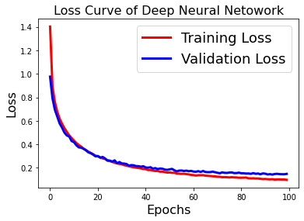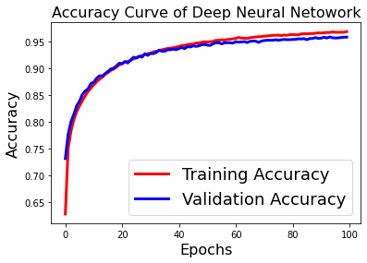

**Figure:** Loss Curve & Accuracy Curve for Subject 6